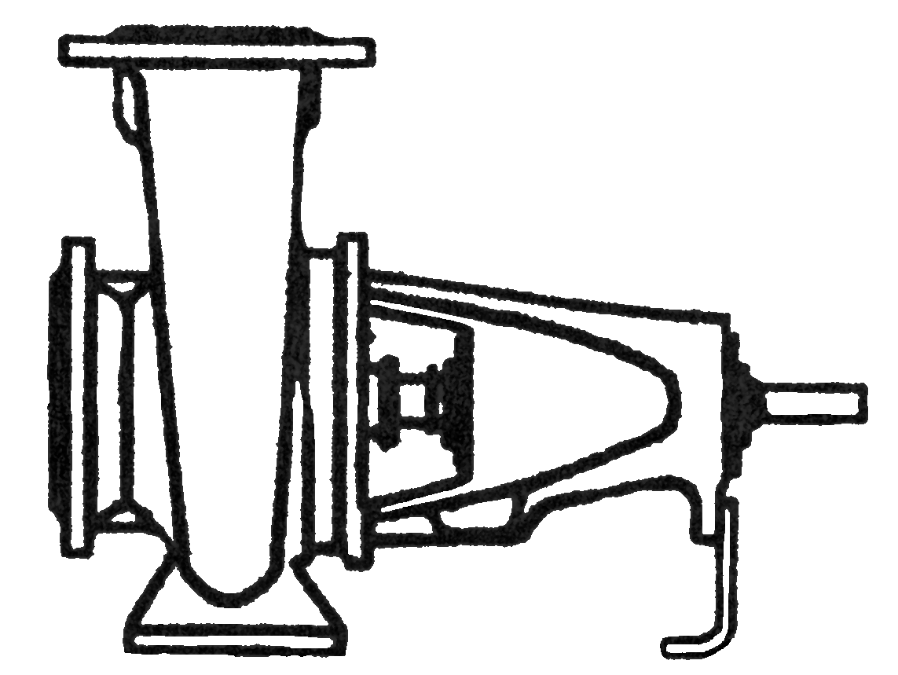

PRODUCT BULLETIN
MODEL REF END SUCTION
Bulletin 300REF
Edition 2c

American-Marsh Model REF End Suction pumps are used in a variety of industries. These rugged and efficient centrifugal pumps are designed for long life and low operational costs. Each model is of the back pull out design so when the need arises for repair or inspection, system piping does not need to be disturbed.

Material Specifications
PART | CONSTRUCTION
PART | BRONZE FITTED | IRON FITTED | NI-RESIST FITTED | 316SS FITTED
Casing | Cast Iron | Cast Iron | Cast Iron | Cast Iron
Impeller | Bronze | Cast Iron | Ni-Resist | 316 Stainless Steel
Shaft Sleeve | Bronze | Bronze | 316 Stainless Steel | 316 Stainless Steel
Shaft | 420 Stainless Steel | 420 Stainless Steel | 420 Stainless Steel | 420 Stainless Steel
Case Wear Ring | Bronze | Cast Iron | Ni-Resist | 316 Stainless Steel
Power Frame | Cast Iron | Cast Iron | Cast Iron | Cast Iron
Bearing Caps | Cast Iron | Cast Iron | Cast Iron | Cast Iron
Bolts, Studs & Nuts | Steel | Steel | Steel | Steel
Mechanical Seal | Carbon/Si-C/Buna | Carbon/Si-C/Buna | Carbon/Si-C/Buna | Carbon/Si-C/Buna

MODEL REF SPECIFICATIONS

Casing: The casing is constructed of high tensile cast iron or other specified material. It is of the volute type, carefully and accurately proportioned to permit smooth flow and to convert high velocity energy of the fluid as it leaves the impeller into pressure. Suction and discharge nozzles are casted integral with the volute and are of 250 psi dimensions. All REF models feature a 250 psi case working pressure. The casing has cast integral feet standard and the discharge port is of the vertical centerline type. Necessary vent and drain openings are provided.

Impeller: The impeller is of the end suction type, casted in one piece of bronze or other specified material. All impellers are hydraulically and dynamically balanced prior to assembly and all impellers have pump out vanes standard on the back side of the imepller to reduce material from building up near the stuffing box.

Case Wear Ring: Standard enclosed impellers are designed with integral case wear rings accurately turned to provide close running fits in casing. The diameters of these rings are such as to reduce end thrust to a minimum. On larger models a rear case wear ring is provided for additional wear resistance.

Shaft: The shaft is of high strength 420 stainless steel, ground to accurate dimensions and polished to a smooth surface. It is designed for extra stiffness to avoid all critical speeds in operation. The shaft is protected by a shaft sleeve of ample thickness to ensure long life. The shaft sleeve can be supplied in various materials.
Casing Adapter: The casing adapter is constructed of cast iron or other specified material. The casing adapter connects the six (6) power frame assemblies to the forty-three (43) casing assemblies. The casing adapter also houses the mechanical seal or packing and has an integral flush line standard for stuffing box lubrication. When the casing assembly is supplied of optional material, the casing adapter is also constructed of the same material due to the fact that it is also in contact with the pumped fluid.

Power Frame: The power frame is constructed of high tensile cast iron and provides support for the inboard and outboard bearings. Each bearing is of the deep grove, single row type designed to carry all thrust and radial loads encountered by the pump. All bearings are sized to maintain a minimum of 50,000 hour bearing life. Each bearing housing is sealed from water leakage by the use of an oil lip seal. The power frame has an integral oil sump that provides oil for lubrication to each bearing. An oil level eye is provided standard on the power frame to visually indicate the oil level.
PRODUCT BULLETINMUNICIPALCOMMERCIALINDUSTRIAL
MODEL REF END SUCTIONQuench Water, Filtration, Transfer,HVAC, Booster, Condensate Return,Process, Petrochemical,
Filter Backwash, CirculationSupply Water, Cooling TowerCargo Transfer

Stuffing Box: The stuffing box is sized for a standard, front loading mechanical seal with integral flush line. The mechanical seal is constructed of a carbon rotary face, a silicon-carbide stationary face and buna elastomers standard. Packing with a lantern ring and internal flush line are optional. Also optional are a wide variety of cartridge mechanical seals.

Bulletin 300REF
Edition 2c

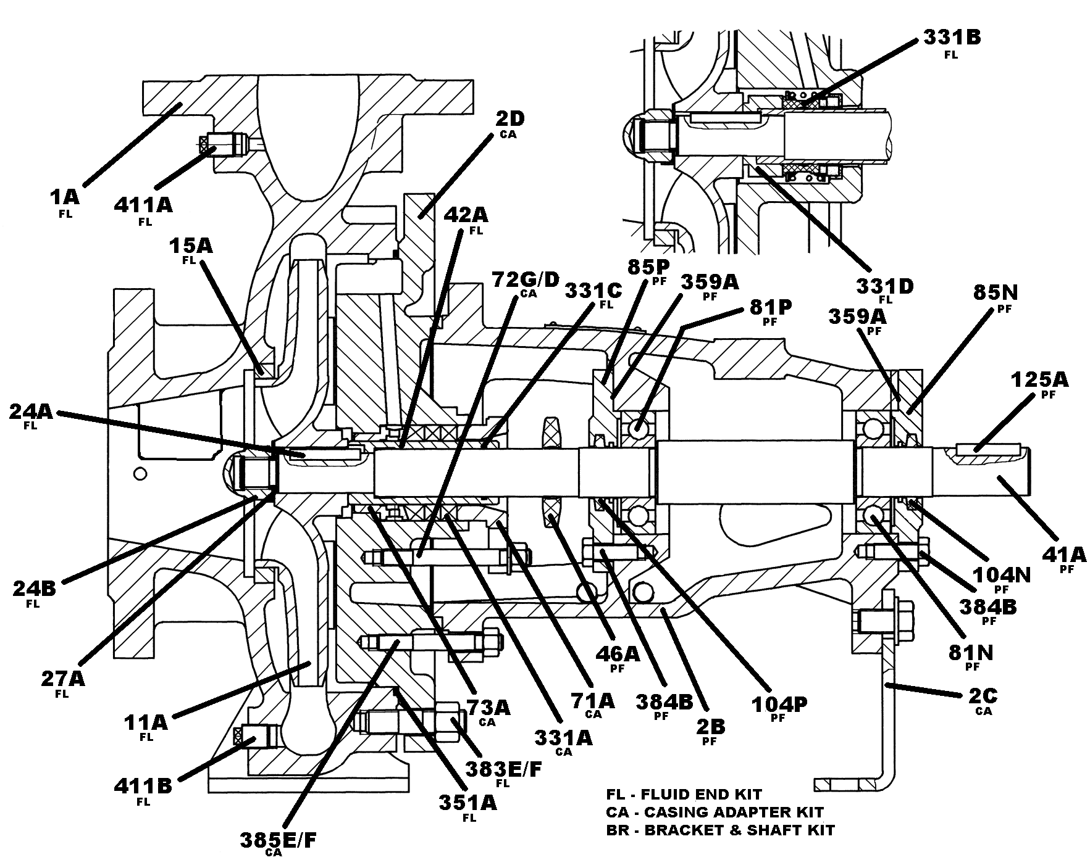

REF Sectional Drawing

Item Number | Item Description | Num. Req. |  | Item Number | Item Description | Num. Req.
1A | Casing | 1 |  | 81P | Inboard Bearing, Radial | 1
2B | Power Frame | 1 |  | 85N | Outboard Bearing Cap | 1
2C | Foot, Power Frame | 1 |  | 85P | Inboard Bearing Cap | 1
2D | Casing Adapter | 1 |  | 104N | Outboard Lip Seal | 1
11A | Impeller | 1 |  | 104P | Inboard Lip Seal | 1
15A | Case Wear Ring, Front | 1 |  | 125A | Coupling Key | 1
15B | Case Wear Ring, Rear | Varies |  | 331A | Packing | 1 Set
24A | Impeller Key | 1 |  | 331B | Mechanical Seal | 1
24B | Impeller Nut | 1 |  | 331C | Shaft Sleeve O-Ring | 1
27A | Impeller Washer | 1 |  | 331D | Mechanical Seal Locking Collar | 1
41A | Shaft | 1 |  | 351A | Casing Gasket | 1
42A | Shaft Sleeve | 1 |  | 359A | Bearing Housing Gasket | 2
46A | Water Slinger | 1 |  | 383E/F | Casing Stud & Nut | Varies
71A | Stuffing Box Gland | 1 |  | 385E/F | Bearing Housing Stud & Nut | Varies
72G/D | Hinge Bolt & Nut | 2 |  | 384B | Bearing Cap Capscrew | 1
73A | Lantern Ring | 1 |  | 411A | Plug, Vent | 1
81N | Outboard Bearing, Thrust | 1 |  | 411B | Plug, Drain | 1
Recommended spare parts are in BOLD.

